Future of sustainable smartphone production: Carbon Mobile announce pioneering initiatives to help solve global E-Waste problem in tech
New programs include Green Reward for customers that recycle their devices and world first bio-based concept device in 2022.

- Carbon Next Recycling Program with 400€ discount for customers returning their device and upgrading to a new model in 2022
- Innovative bio-based carbon fiber alternative set for 2022 premier
- Carbon 1 MK II becomes the world’s first plastic neutral smartphone
- Material Innovation: cutting E-Waste at the source & reducing materials required by 33%

Berlin, July 6, 2021: Berlin-based start-up, Carbon Mobile is taking the first step towards a more sustainable future for mobile devices with a focus on the 50m Tons a year E-waste problem. CEO, Firas Khalifeh announces today that as part of their Carbon Next recycling scheme, customers can receive a generous EUR 400 ‘Green Reward’ discount when upgrading to the next generation of their Carbon 1 smartphone in 2022. At the same time, the manufacturer is announcing the exciting development of the world’s first bio-based carbon fiber smartphone with a concept device due next year.

"Our engineers are today working with Europe's leading materials researchers to create the first carbon fiber smartphone from bio-based sources including wood waste and flax plants," explains Firas Khalifeh. Carbon Mobile is confident the revolutionary new processes developed for the Carbon 1 MK II, have made it possible to truly explore the potential of these ground-breaking green alternatives for the first time.

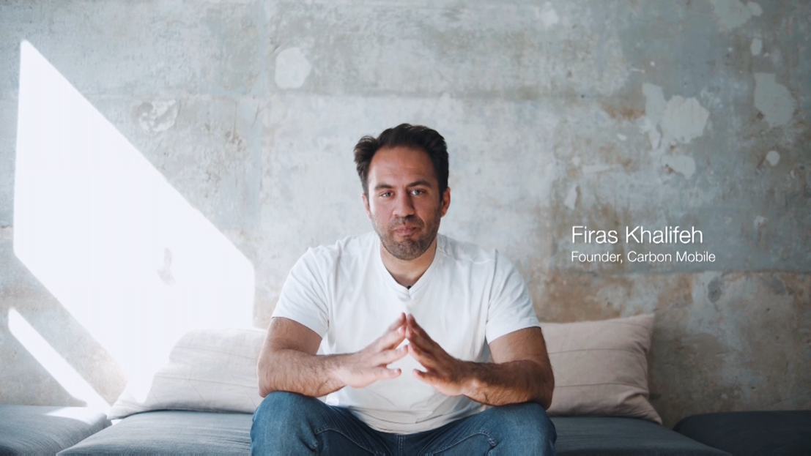
Watch the video: Carbon Mobile introduce their innovative approach to tackling E-waste

Carbon Next: Closing The Loop On E-Waste
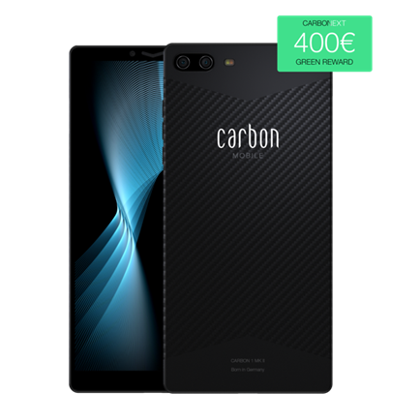
With the 400€ Green Reward, Carbon Mobile want to help close the loop on E-waste by encouraging Carbon Mobile users to return their old devices and fuel the research into their Carbon Next recycling initiative. “The Carbon 1 MK II is built with valuable carbon fiber material: recovering, recycling and re-engineering this resource into the next generation of devices is a vital step in the lifecycle management of our products,” says Firas Khalifeh.
From today, all new Carbon Mobile customers that purchase before 20th August 2021 will automatically qualify for the program, and existing Carbon 1 MK II owners can register for the limited-time buyback program at carbonmobile.com/sustainability.
World’s first plastic neutral smartphone
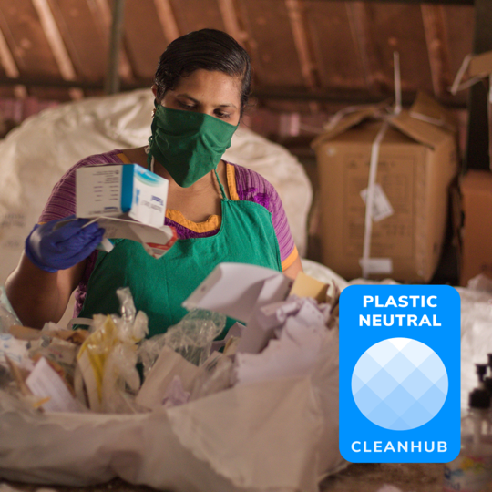
Carbon Mobile’s goal is to accelerate the adoption of more sustainable materials in tech and end the era of cheap an difficult to recover plastics. Every year over 50M tons of E-waste is produced. Mobile devices contribute significantly to the waste pile with sustainability commonly ignored in the production of over 1.3 billion mobile devices sold annually. Firas Khalifeh wants to change this: "Longer-lasting mobile devices without plastics are not only good for consumers, but also for the planet. At Carbon Mobile, our goal is to make products that are reliable, easy to repair and recyclable. "

The Carbon 1 MK II is already built with less than 10% plastic and all plastic is removed in their mono-paper packaging. To reinforce their intentions for a greener and cleaner future, they have partnered with Cleanhub in their bid to go fully plastics neutral. For every Carbon 1 MK II sold; the company commit to collecting 500 grams of ocean bound waste plastic. At 4 times the weight of the device, Carbon Mobile can boast it is the world's first plastic-neutral smartphone.

Joel Tasche, CEO Cleanhub "We’re very excited to partner with Carbon Mobile and work with them to reduce the impact of plastics waste in the tech sector. This is a global problem that has built up over time and I’m excited to see Carbon putting a product on the market with significantly less plastic and on top do whatever they can to reverse plastic pollution."

Material Innovation: The potential to save 100K Tons of raw materials
Thinner, lighter, stronger and more sustainable; high-performance materials offer the greener alternative to the damaging plastics and metals the sector relies on. With its incredibly light and thin monocoque design, the Carbon 1 MK II represents the potential for the future. Using 33% less materials than the average competitor device, if all mobile devices were built in this way, it could save 100,000 tons of the earth’s resources every year - enough to fill 3,500 shipping containers.

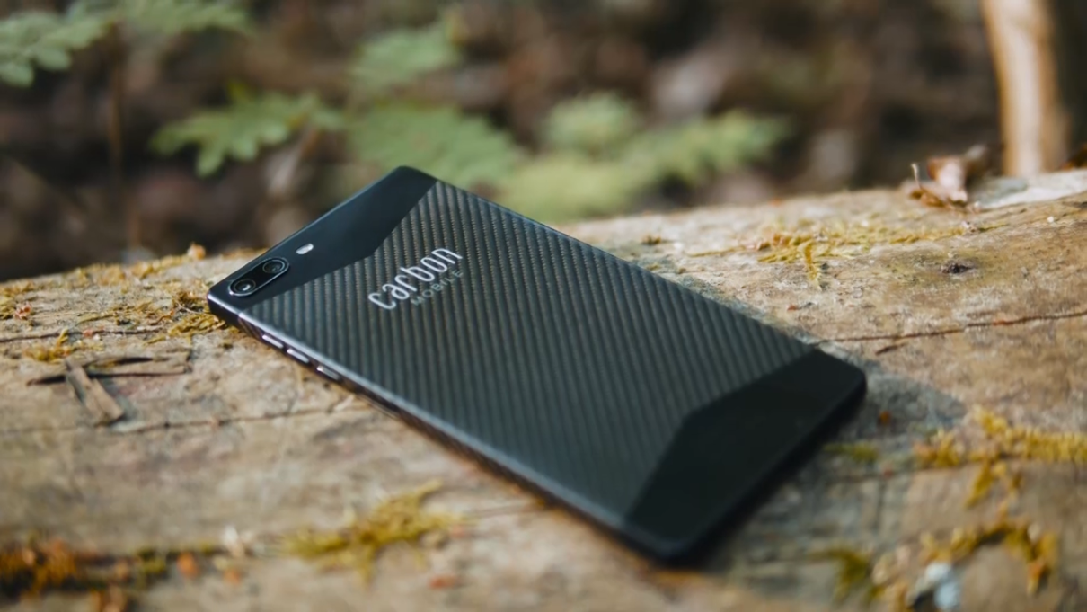

Carbon Mobile is the only electronics manufacturer to rely on their patented HyRECM technology, a hybrid material with all the benefits of carbon while also being "radio friendly" to eliminate connectivity issues. The material is considered as a breakthrough in material science and is characterized mainly by its strength and light weight, which allowed the development of the lightest (125 grams) and thinnest (6.3 millimeters) smartphone made of carbon fiber to date.

Carbon 1 MK II: Available in stores and online
The Carbon 1 MKII is available to buy from Carbonmobile.com as well as instore and online from household from a number of key partners across Europe:
DACH: Amazon, MediaMarkt, Conrad, Digitec, Otto
BENELUX: Belsimpel, Fnac, Mobiel.nl
Full campaign video: Here
More information on Carbon Mobile’s innovations and supporting images here.

Press Contact
Havana Orange GmbH
Samet Simsek
+49 89 92 131 51 78 / -70
carbon@havanaorange.de

Innovation designed in Germany
Carbon Mobile GmbH, based in Berlin, is a German technology company with a great vision: to be the new European alternative with a diverse portfolio in the field of consumer electronics. In doing so, Carbon Mobile wants to shake up a sluggish and saturated market that is hungry for innovation and initiate a rethink towards sustainable production.

